Business Case Analysis – Migrating from Paper-based Records to Electronic Health Records
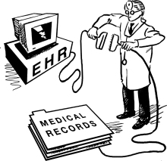

Client: MedPractice, LLC
Company: R.O.P. Solutions
Author: Rolando Phillips

Overview

The Business Case Analysis deals with a hypothetical situation in which a CEO of a busy medical practice (MedPractice, LLC) has hired a data communications solutions company (R.O.P. Solutions) to modernize her company. R.O.P. Solutions has been tasked with the following:
- Modernize MedPractice, LLC so the company can utilize EHRs (Electronic Health Records) and ePrescribing
- Improve the existing data communications infrastructure to meet the security and patient confidentiality requirements established under HIPAA
The first task at hand for R.O.P. Solutions involves defining the existing business operations for MedPractice, LLC, specifically:
- What functions are performed?
MedPractice, LLC is a busy, primary care medical practice with multiple rooms on one floor of a multiple story building. The company has three physicians with two assistants each, two receptionists/front desk personnel, and one office manager.
- How are the functions performed now with estimated costs?
The company relies heavily on paper-based records for filing, scheduling, and billing. This has made it very difficult for MedPractice, LLC to implement many of the requirements of EHRs, and they seek assistance with developing an integrated solution encompassing EHR adoption, electronic scheduling, and e-billing.
The next tasks for R.O.P. Solutions deal with a detailed analysis of EHRs, EHR adoption at similar facilities, HIPPA confidentiality and security requirements, and the steps involved in designing and installing a modern networking solution for the medical practice.

Paper-Based Records in Medical Practices

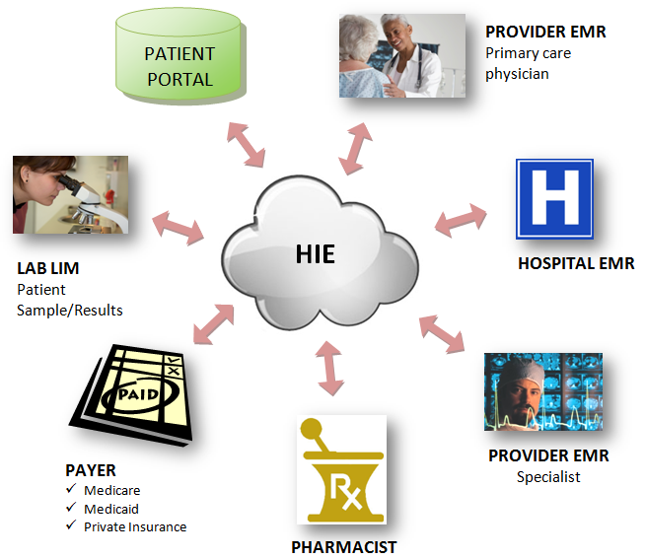

The above graphic demonstrates the promise of electronic health records. Utilizing the cloud, patient medical historical information is accessible by pharmacists, hospitals, insurance companies and organizations, individual physicians, medical labs, and all other key stakeholders. Changes to medical histories are updated almost instantly across all systems, and the inefficiencies associated with paper-based records are completely done away with. Of course, in the real world things often do not operate so smoothly, even when outdated methods and technologies are upgraded. However, one can not underestimate the significant advantages that electronic health records have over paper-based records.
Paper-based records are inherently time-consuming. A considerable amount of time is wasted sorting, filing, and retrieving information from paper-based records. Another source of delays in busy medical practices is the lack of “standard interfaces with external entities” in many IT systems in these offices (Ramaiah, Subrahmanian, Siriam, and Lide). When designing a data communications solution for a medical practice, care must be taken to ensure that all clients in the system interface properly with external systems to facilitate information sharing and data exchange.
Insurance verification is another task that has historically been done using a combination of paper-based records and telephone conversations. There are numerous insurance companies with which medical practice front desk personnel must interact, and the companies often have different methods for accomplishing the same tasks. Insurance verification using traditional methods is subject to multiple errors and is time consuming at each step of the process. Additional problems associated with paper-based record keeping include scheduling and patient registration. These tasks can be very time consuming and EHR automates and or eliminates many of the functions associated with these activities such as the time spent collecting information from a patient's previous physicians.

Electronic Health Records (EHRs)
The functions in many medical practices can be categorized as follows: registration, insurance verification, vitals, patient history, patient consultation, prescription, procedure, referral, certificates, appointments, labs, and billing. MedPractice, LLC currently handles all of these tasks using paper-based records and telephone conversations. The computers in the office have office productivity software installed on each PC, but they are not networked making information sharing and tracking difficult and cumbersome.
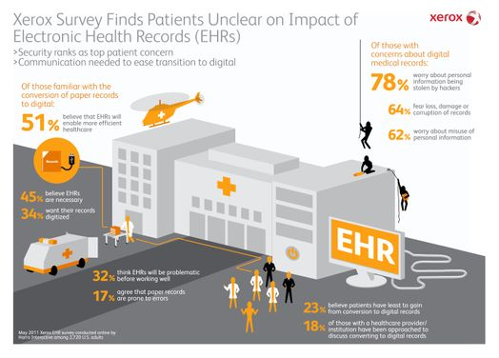
Though there are numerous benefits associated with EHRs, many patients continue to feel that digitized records are inherently not secure. According to a 2011 survey conducted by Xerox, almost 80% of survey participants felt that their personal, medical histories were more likely to be stolen by computer hackers if the records were stored as EHRs (xerox.com). Clearly, more must be done to convince the general public that EHRs are indeed secure when the systems utilizing the records are implemented correctly.

According to HealthIT.gov, electronic health records are much more than digitized versions of paper patient records. When properly implemented, EHRs serve as a central repository that can store a patient's entire medical history. Information such as diagnoses, immunization dates, x-rays, allergies and lots of other data can be stored within EHRs. Health providers' workflows can also be streamlined as many processes can be automated. An additional benefit is that EHRs can be accessed with any web-enabled device over secure connections which can lead to increased productivity via information sharing.

EHR Adoption
By August 2012, more than 50% of Medicare and Medicaid-enabled health professionals had registered for the “meaningful use incentive program” component of the Health Information Technology for Economic and Clinical Health (HITECH) Act (healthit.gov). Meaningful use comprises a set of standards that must be met by eligible professionals in order to receive incentive payments from the Centers for Medicare & Medicaid Services (CMS) for implementing EHRs.
In the paper, “Workflow and Electronic Health Records in Small Medical Practices”, the authors suggest that physicians with specialties are “more favorable toward adopting EHR systems than primary care physicians” (Ramaiah, Subrahmanian, Siriam, and Lide). Many primary care physicians have been slow to convert to EHRs due to the complex, non-standardized workflows involved in their medical practices. In addition, many primary care practices could benefit from digitized records if EHRs “could interact with external entities” (Ramaiah, Subrahmanian, Siriam, and Lide). These issues make the transition to digitized records particularly challenging for a primary care practice such as MedPractice, LLC.

Specialty medical practices seem to have adopted EHRs and digitized records due to the standardization inherent in these offices. The standard procedures involved in the organization and storage of patient records and the limited variety in the types of patients seen at specialty offices make these practices ideal candidates for computerization. Primary care offices are more challenging. These practices see a larger variety of patients and communicate with a greater number of external entities many of whom use different methods of communication. A more sophisticated analysis of these practices is required when building a data communications solution.

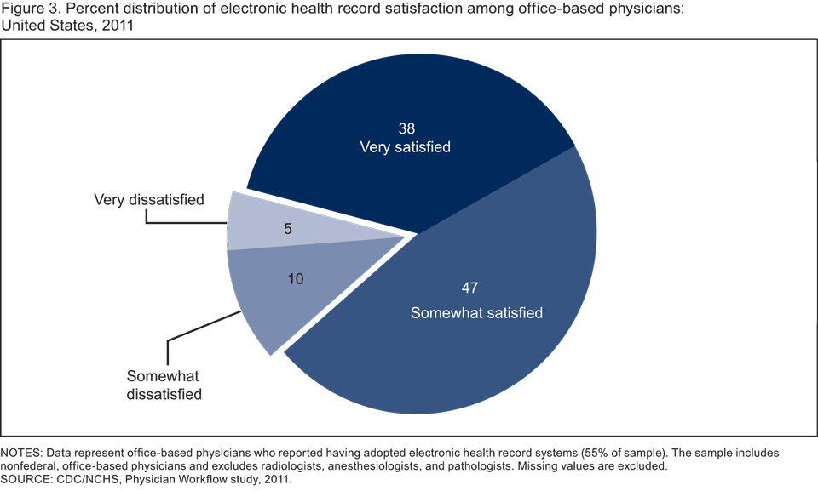
Source: cdc.gov
According to the chart above from a 2011 electronic health record satisfaction report from the Centers for Disease Control and prevention, 85% of non-federal, office-based physicians are satisfied with the performance of their electronic health record systems. Almost 40 % of those physicians surveyed reported being very satisfied with the new systems. These findings suggest that once the transition to an EHR system has been made, the majority of medical offices greatly appreciate the multiple benefits associated with the move to digitized records.

When adopting and implementing a fully functional EHR system, success is often determined by paying close attention to office workflow. Care must be taken to ensure that the frameworks within which office operations occur are analyzed carefully to decrease the amount of time spent learning the new system.

HIPAA, Privacy, and Security
The Health Insurance Portability and Accountability Act (HIPAA) was enacted in 1996, and it includes a number of provisions designed to protect health care coverage for workers and ensure that the information contained in EHRs remain secure. There are two primary rules contained in the act that address privacy and security. The HIPAA privacy rule “provides federal protections for individually identifiable health information held by covered entities and their business associates and gives patients an array of rights with respect to that information” (hhs.gov). The HIPAA security rule has “technical safeguards” to maintain the “confidentiality, integrity, and availability of electronic protected health information” for patients (hhs.gov). These two rules combined form the basic framework within which medical practices and other healthcare professionals must operate when adopting and implementing digitized records.
Security and privacy are always critically important, but these issues are especially important when dealing with confidential patient records. In 2015 the Office of the Inspector General will “continue to pay closer attention to the healthcare industry's use of electronic health records—in particular HIPAA security” (healthcareITnews.com). It is paramount for medical practices and other eligible health professionals to properly adopt and implement EHRs and ensure that their activities address regulatory and security concerns.
LAN Design
When designing a Local Area Network (LAN) for any business one of the primary issues to consider is the relationship between wired Ethernet and Wi-Fi in the office environment. With the introduction of 802.11n, Wi-Fi offers data rates comparable to wired 100BaseT- Ethernet with a substantial reduction in price due to less wires being used (Dennis and Fitzgerald pg. 218). However, one must consider the security challenges that come along with wireless networks especially regarding EHRs and HIPAA compliance. The number of users simultaneously using the LAN must also be considered since Wi-Fi shares its circuit and available capacity to every user on the same access point.

For the client, a combination of wired Ethernet and Wi-Fi will be used as the LAN design. Switched Ethernet (100Base-T over category 5e UTP wiring) will be used as the primary LAN for the desktop users in the office and Wi-Fi will be used for users with laptops and mobile devices. A site survey was conducted, and it was determined that one access point should be sufficient at this time. For maximum data rates, the access points will be placed in areas that are approximately 70 square feet---this translates into a 50-foot radius for each access point (Dennis and Fitzgerald pg. 221). Existing computers will be inspected to see if additional equipment such as Network Interface Cards (NICs) must be purchased or if an entirely new suite of PCs must be purchased. Most of the existing computers are desktops, and it was determined that these units will be replaced with laptops due to the increased mobility and space advantages. Please review the attached network diagram for a visual representation of the new network.

References
At Cerner, interoperability is personal. (n.d.). Retrieved November 06, 2014, from http://www.healthcareitnews.com/news/cerner-interoperability-personal

Centers for Disease Control and Prevention. July 17, 2012. Accessed December 12, 2014. http://www.cdc.gov/nchs/data/databriefs/db98.htm.

FitzGerald, J., Dennis, A., & FitzGerald, J. (2012). Business data communications and networking. New York: Wiley.

HealthIT.gov. (n.d.). Retrieved November 02, 2014, from http://www.healthit.gov/providers-professionals/faqs/what-electronic-health-record-ehr

HealthIT.gov. (n.d.). Retrieved November 02, 2014, from http://www.healthit.gov/providers-professionals/learn-ehr-basics

More EHR audits to come in 2015. (n.d.). Retrieved November 06, 2014, from http://www.healthcareitnews.com/news/more-ehr-audits-come-2015

"Patients Need Assurance That Electronic Health Records Are Secure, Xerox Survey Says." Xerox Survey Shows Impact of Electronic Health Records. Accessed December 14, 2014. http://news.xerox.com/news/Xerox-Survey-Shows-Impact-of-Electronic-Health-Records.

Understanding Health Information Privacy. (n.d.). Retrieved October 28, 2014, from http://www.hhs.gov/ocr/privacy/hipaa/understanding/index.html

Workflow and Electronic Health Records in Small Medical Practices. (n.d.). Retrieved November 01, 2014, from http://perspectives.ahima.org/workflow-and-electronic-health-records-in-small-medical-practices/#.VFckrvnF-So

